Task 01:

What is a Process?
A process is like a program that is currently running in our system and when we open an application, it starts a process for it.

Task 02:
What is a Thread?
A thread is like a smaller unit within a process that helps a program do many tasks at the same time. For example, in a web browser (which is a process), one thread might load a webpage, another might play a video.

Task 003:
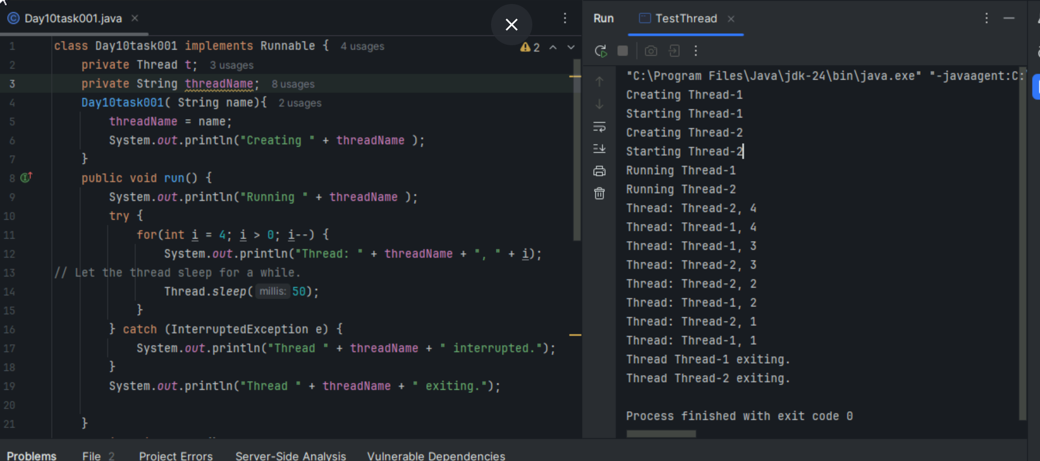

Task 004:
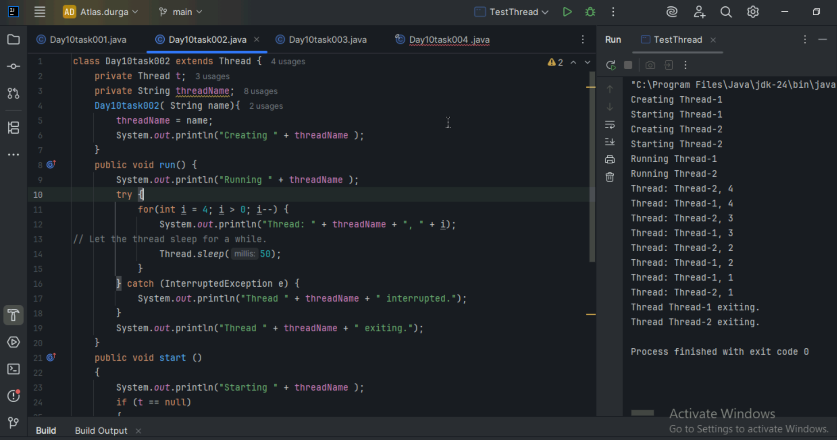

Task 005:
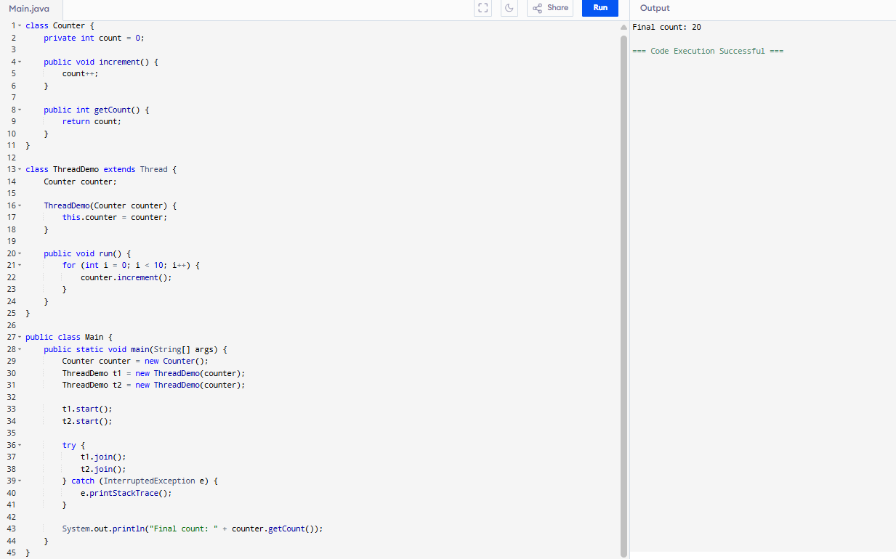
Task 006:
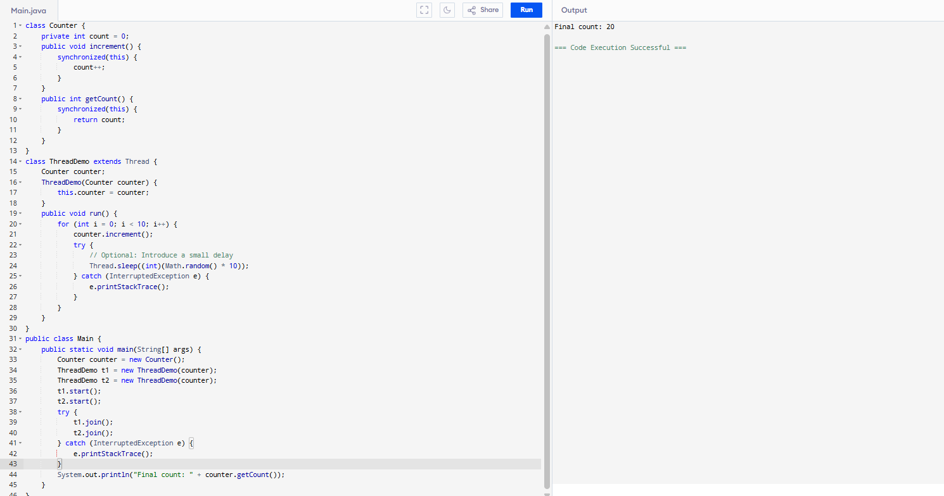

Task 007:
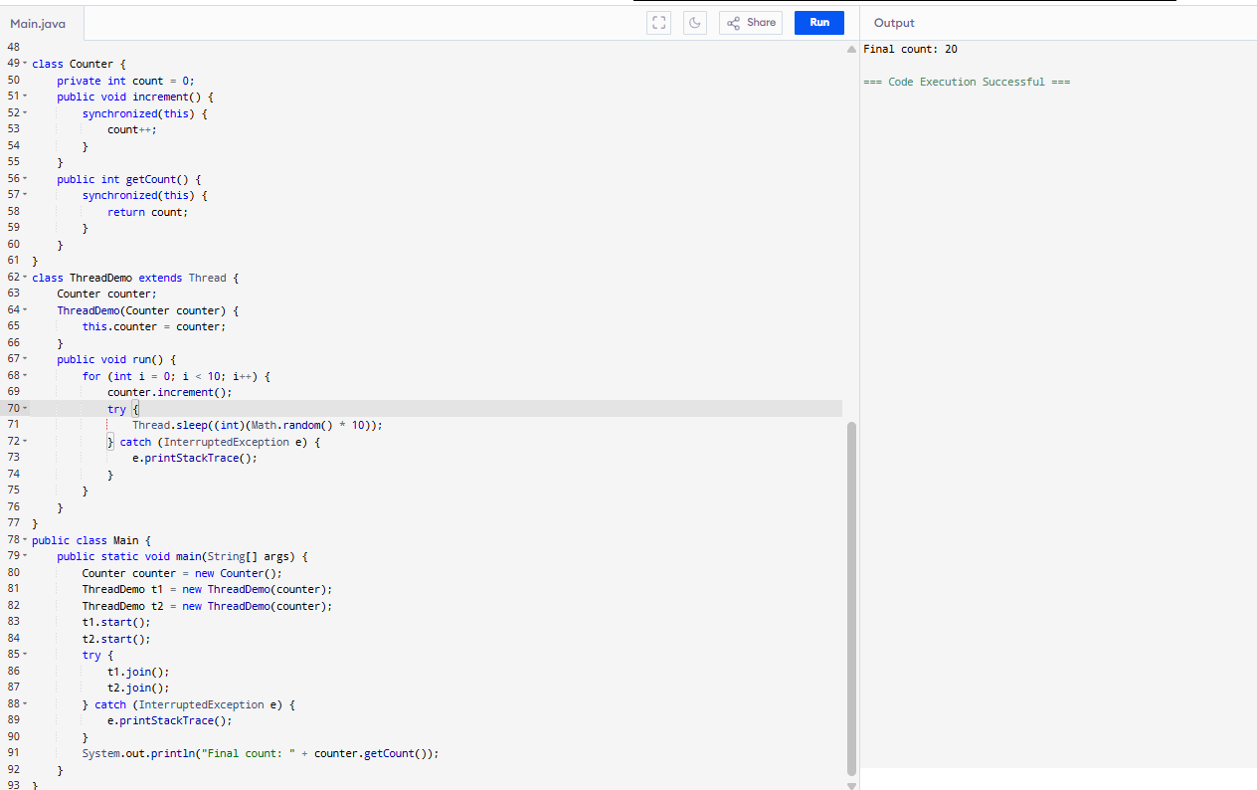

Task 008:
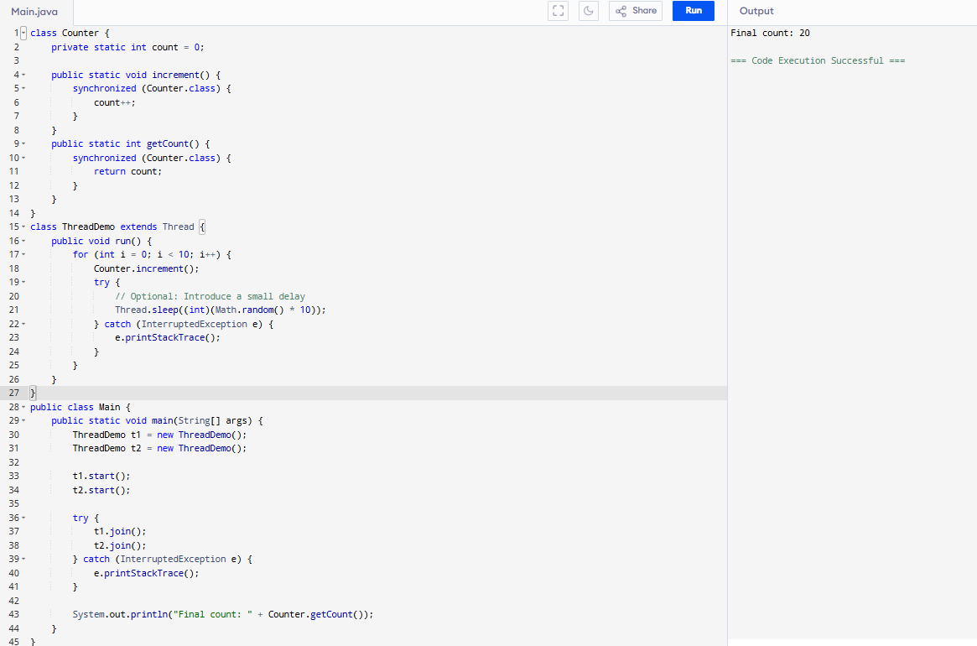
Task 009:
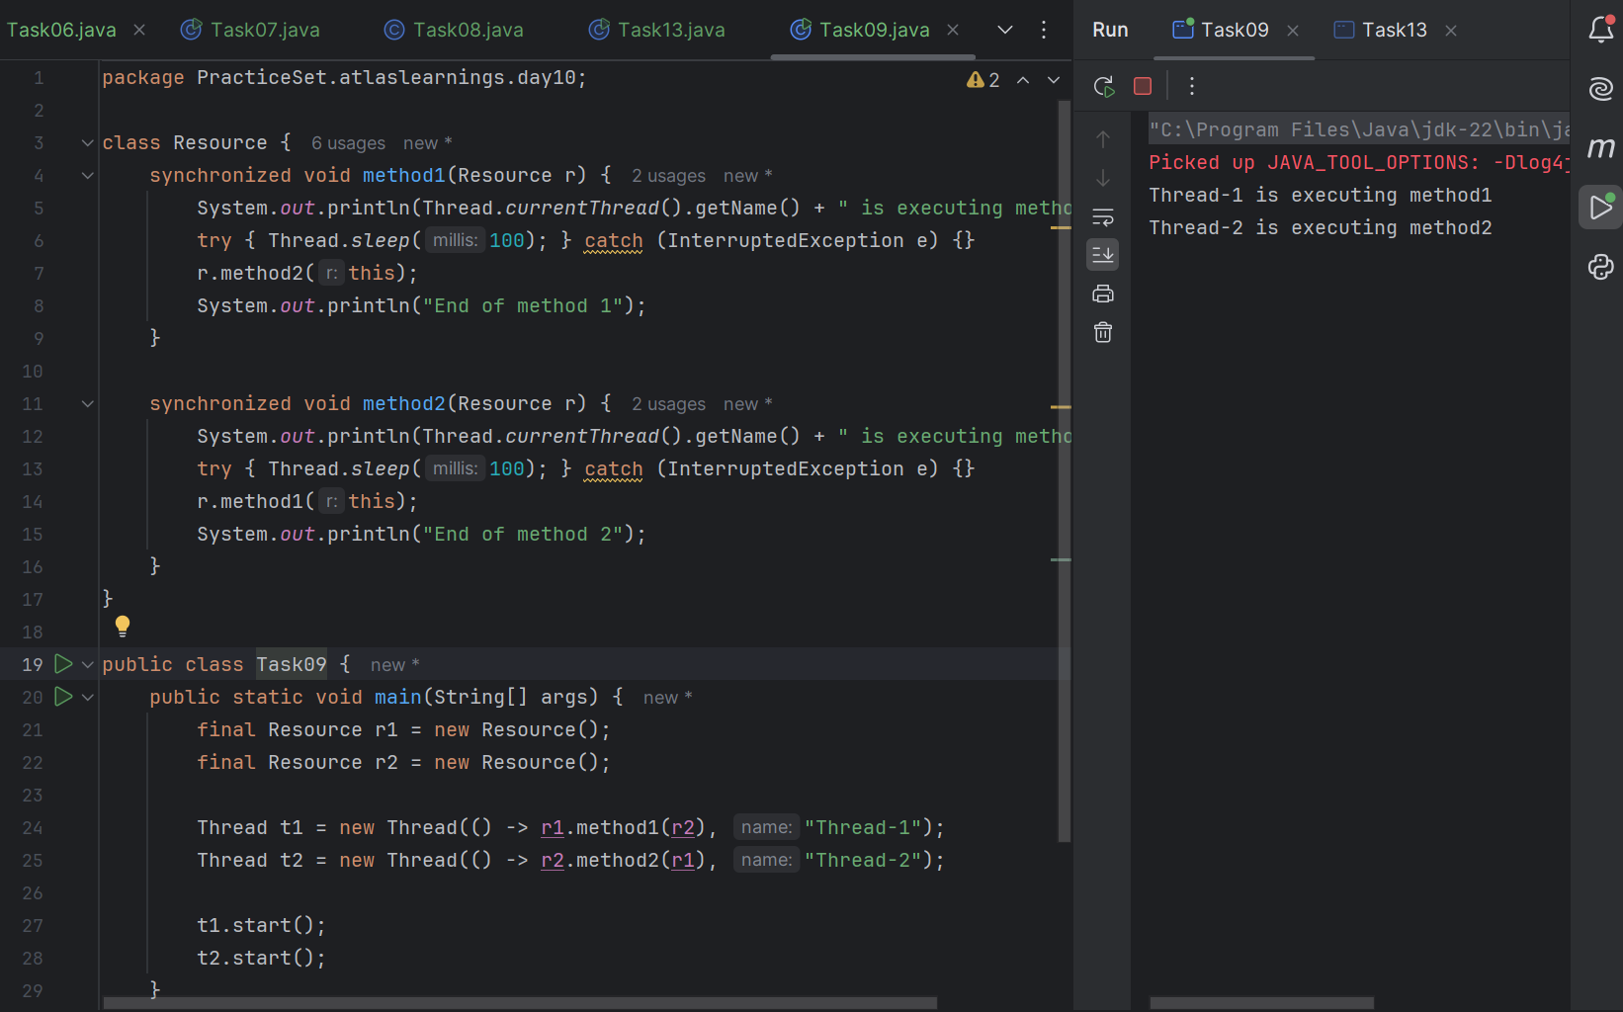

Task 10:
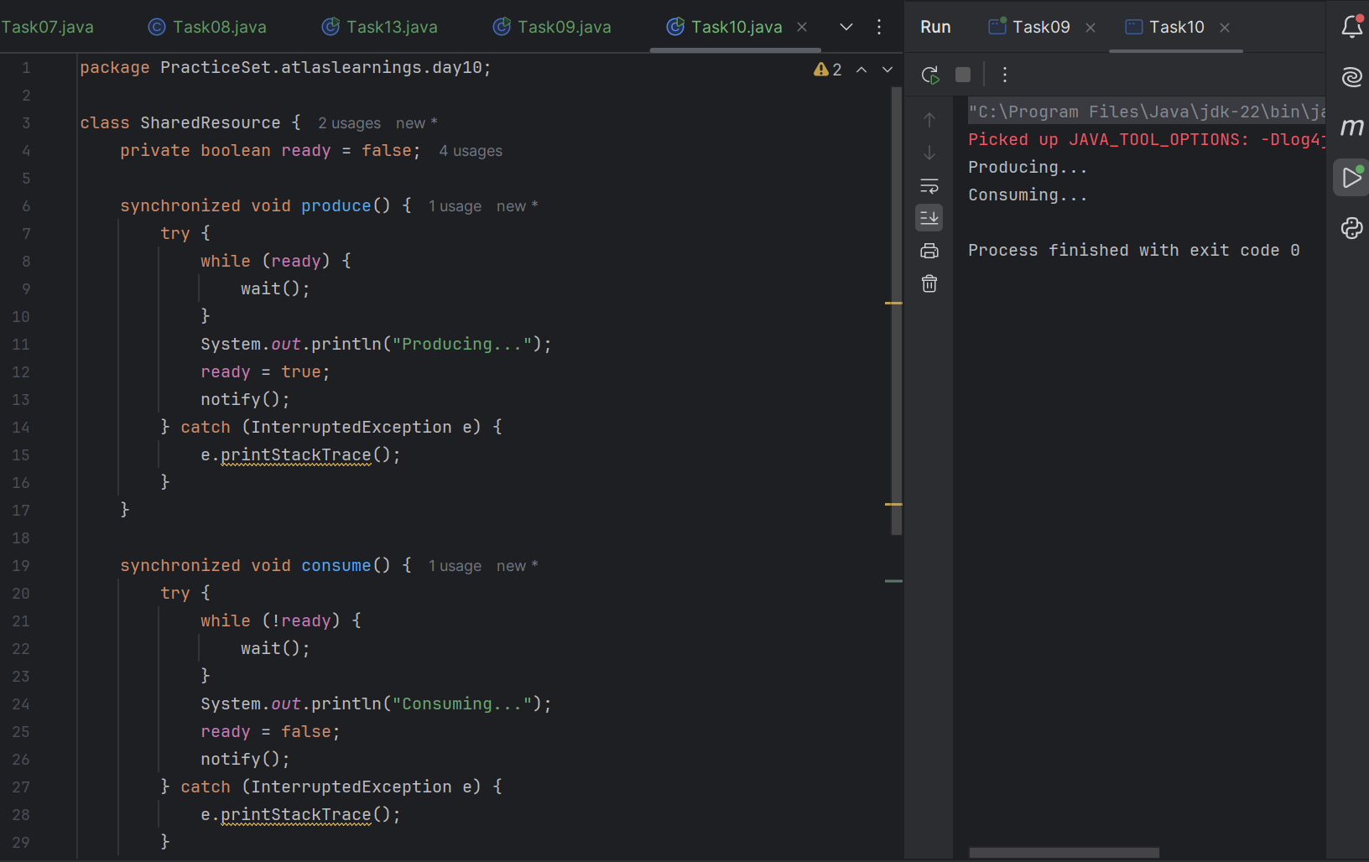
Task 11:
Inter- thread communication…

class SharedResource {
// Defines a class named SharedResource which will handle the shared resource logic between threads.
private boolean ready = false;
// Declares a private boolean ready initialized to false. This flag tracks whether the resource is ready for consumption.

synchronized void produce()
// Defines a synchronized method produce(), ensuring that only one thread can execute it at a time.
{
try
// Starts a try block to handle potential InterruptedException during execution.
{
while (ready) {
wait();
}
// Checks if ready is true. If so, the thread waits, releasing the lock on the object until notified.
System.out.println("Producing...");
// Produces the resource by printing "Producing...".
ready = true;
// Sets ready to true, indicating the resource is now ready for consumption.
notify();
// Notifies a waiting thread, waking it up to continue execution.
} catch (InterruptedException e) {
e.printStackTrace();
}
// Catches and prints any InterruptedException if the thread is interrupted during wait()
}
synchronized void consume() {
// Starts a try block to handle potential InterruptedException.
try {
while (!ready) {
wait();
}
System.out.println("Consuming...");
// **Checks if `ready` is false**. If so, the thread waits, releasing the lock until notified.
ready = false;
notify();
// **Sets `ready` to false**, indicating the resource has been consumed and is no longer ready.
} catch (InterruptedException e)
// **Catches and prints** any `InterruptedException` during `wait()`.

// ### Main Method
{
e.printStackTrace();
}
}
}

public class InterThreadCommunicationExample {
public static void main(String[] args) {
SharedResource resource = new SharedResource();

Thread producer = new Thread(resource::produce);
Thread consumer = new Thread(resource::consume);
// **Creates two threads**: one for the `produce` method and one for `consume`.

producer.start();
consumer.start();
}
}

This is what I understand the Inter- thread communication…

Task 12:
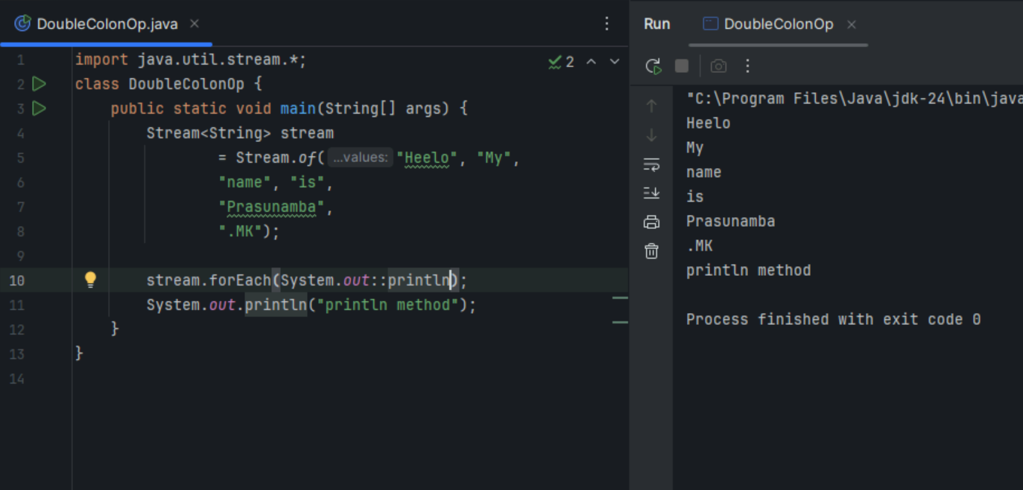
Task 13:
Interrupting a thread
Example of Interrupting a Thread
class InterruptibleThread extends Thread
// Defines a class InterruptibleThread that extends the Thread class, allowing it to be executed in a separate thread.
{
public void run()
// Overrides the run method from the Thread class. This is where the thread's work happens.
{
try
// Starts a try block to handle any InterruptedException that may occur.
{
while (!Thread.currentThread().isInterrupted())
// Loop condition: Continuously checks if the current thread has been interrupted.
{
System.out.println("Thread is running");
// Prints a message indicating that the thread is alive and functioning.

Thread.sleep(100);
// Puts the thread to sleep for 100 milliseconds, simulating some work being done.
}
} catch (InterruptedException e) {
System.out.println("Thread was interrupted");
}
}
}
// Catches InterruptedException: If the thread gets interrupted during sleep(), it exits the loop and prints "Thread was interrupted".

public class InterruptExample
// Defines the main class InterruptExample that contains the main method to test thread interruption.
{
public static void main(String[] args) {
InterruptibleThread thread = new InterruptibleThread();
// **Creates an instance** of `InterruptibleThread`
thread.start();
// Starts the thread, triggering its run method.
try {
Thread.sleep(500);
thread.interrupt();
} catch (InterruptedException e) {
e.printStackTrace();
}
}
}
// -Pauses the main thread for 500 milliseconds to allow `InterruptibleThread` to run.
// - Interrupts the thread using `thread.interrupt()`, which causes the loop to break and the `run` method to end.
// - Catches and prints any `InterruptedException` that occurs in the main thread during `sleep()`.
// ### What It Does
// - Purpose: Demonstrates how to use thread interruption in Java. The thread runs in a loop, checking if it has been interrupted. If interrupted, the loop exits and the thread stops gracefully.
// - Usage: Useful when you need to terminate a running thread safely, ensuring resources are managed properly without abrupt stops.

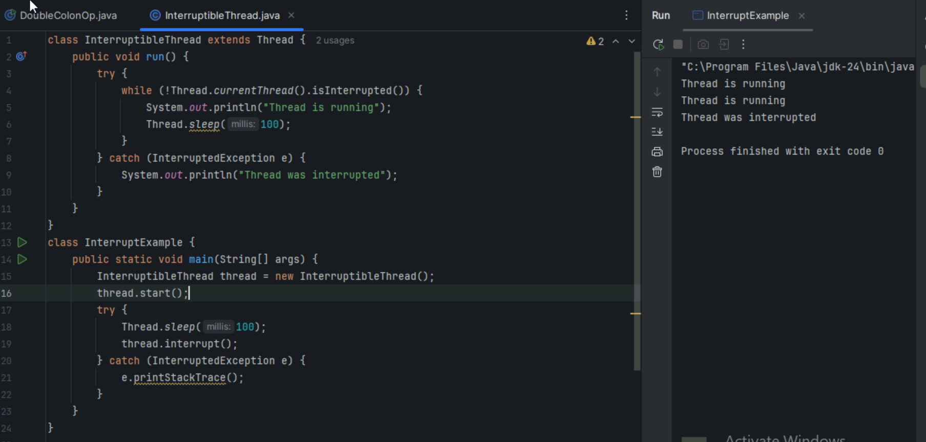

Task 14:
What are Daemon threads? Explain…
Daemon Threads: These are background threads that run in the JVM. They provide services like garbage collection, and they don't prevent the JVM from exiting when the program finishes.
Background Tasks: They're ideal for tasks that should continue running in the background but don't need to block the program from shutting down.
Automatically Terminate: When all non-daemon threads (regular threads) finish, daemon threads automatically stop.
Create a Thread: Just like a regular thread.
Set as Daemon: Before starting the thread, call setDaemon(true)
Thread thread = new Thread(() -> {
// Task code
});
thread.setDaemon(true); // Marks it as a daemon thread
thread.start();
Non-blocking: Daemon threads don't block the JVM from exiting.
Use with Care: Since they can terminate unexpectedly when the main program ends, avoid using them for tasks that need to complete reliably.

Task 15
